# **How to build GNAUpdaterSDK Demo**

Environment:

Windows 10 - using previous versions might require additional features installation.  
MS Visual Studio 2017 Professional Update 3 - build tools v141 are required, it could be troublesome trying to install it on previous versions.  
**Important:** *%GNAUPDATERSDK_PATH%* environment variable should be set in order to locate the SDK executables.

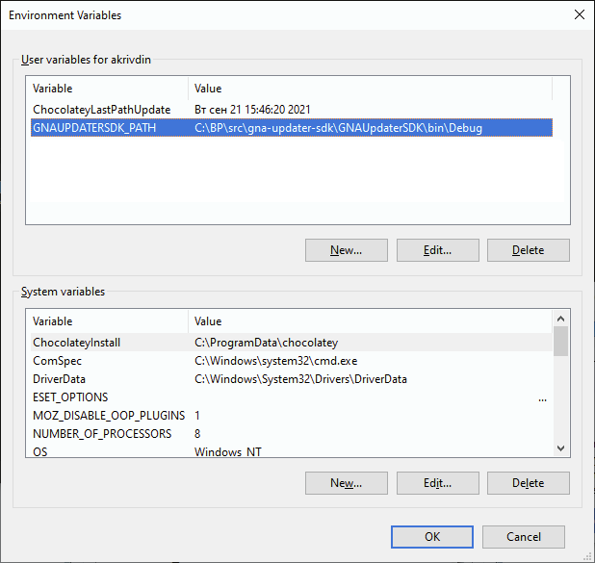

Step-by-step instruction:

1. Install MS VS 2017.
2. Download .net framework 4.7.2 dev pack:  
   [Download .NET Framework 4.7.2 Developer Pack Offline Installer](https://dotnet.microsoft.com/en-us/download/dotnet-framework/thank-you/net472-developer-pack-offline-installer)
3. Get the code.
4. Open …src\gna-updater-sdk-demo\GNAUpdaterSDK_Demo.sln in Visual Studio.  
   You’ll be prompted to install any missing features:

Click “Install“ and then proceed through VS installer to add missing features to be able to build the necessary projects. You’ll need to reopen the VS with the solution after the installation.

1. Select Build > Build solution.  
   All dependencies should install automatically, however you are able to force nuget packages installation by right-clicking the solution and selecting “Restore NuGet Packages“.

Troubleshooting:

**Dependency packages are not resolved in VS:**

in NuGet Package Manager console:

|  |
| --- |
| Update-Package -reinstall |

or, if you know the specific missing package name

|  |
| --- |
| Update-Package -reinstall <Package-Name> |